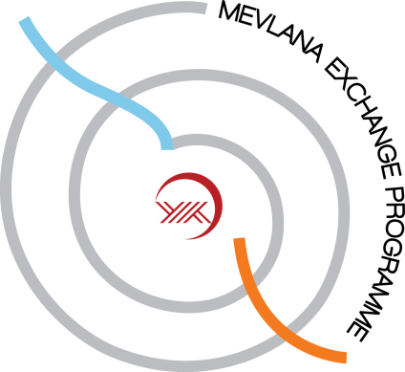

ÖD: Öğrenci Değişimi SE: Student Exchange

Alan kodu  Field code |  | Derece  Degree |  |  |  | Yükseköğretim Kurumu  Higher Education Institution |  | Toplam  Total
Kod  Code | Ad  Field Name | Ön Lisans  Associate Degree | Lisans  Bachelor Degree | Yüksek Lisans  MA | Doktora  PhD | Gönderen  Home Institution | Kabul eden  Host Institution | Öğrenci Sayısı  Student Number | Değişim Süresi (Ay)  Exchange Duration (Month)
12.1 | Medical School |  | 4 |  |  | Batumi Shota Rustaveli StateUniversity | Sifa University | 4 | 1 semester or 2 semesters
 |  |  | 4 |  |  | Sifa University | Batumi Shota Rustaveli StateUniversity | 4 | 1 semester or 2 semesters
12.3 | Dentistry School |  | 2 |  |  | Batumi Shota Rustaveli StateUniversity | Sifa University | 2 | 1 semester or 2 semesters
 |  |  | 2 |  |  | Sifa University | Batumi Shota Rustaveli StateUniversity | 2 | 1 semester or 2 semesters

ÖEH: Öğretim Elemanı HareketliliğiASM: Academic Staff Mobility
Alan Kodu  Field Code | Ders Verilen Alan veya Faaliyetler  Field of Teaching or Activities | Öğretim Üyesi Sayısı  Number of Academic Staff | Yükseköğretim Kurumu  Higher Education Institution |  | Dönem Olarak Toplam Süre  Total Duration in Period | Haftalık Ders Saati  Weekly Course Hour
 |  |  | Gönderen  Home Institution | Kabul eden  Host Institution
12.1 | Medical School | 4 | Batumi Shota Rustaveli StateUniversity | Sifa University | 1 week to 3 weeks | 6
 |  | 4 | Sifa University | Batumi Shota Rustaveli StateUniversity | 1 week to 3 weeks | 6
12.3 | Dentistry School | 2 | Batumi Shota Rustaveli StateUniversity | Sifa University | 1 week to 3 weeks | 6
 |  | 2 | Sifa University | Batumi Shota Rustaveli StateUniversity | 1 week to 3 weeks | 6

