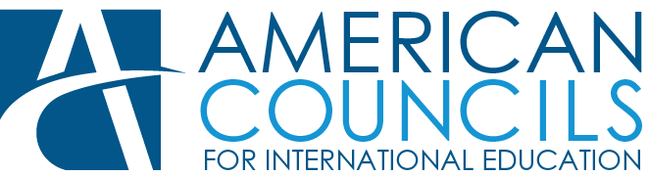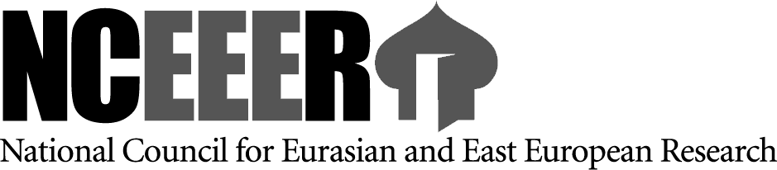

The Carnegie Research Fellowship Program
presentation
will take place on Friday April 1, at 6:00 p.m.
on ……

This FREE competition-based program provides research opportunities in the USA (four-month fellowships) for graduate students, scholars, faculty, researchers in the humanities and social sciences from Armenia, whose research projects are focused on the subject – The South Caucasus. Life In Transition.

The deadline for application is April 30, 2016

Details: www.nceeer.org
www.americancouncils.ge
alexei@nceeer.org
+995322292106

