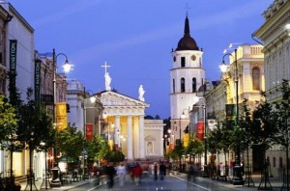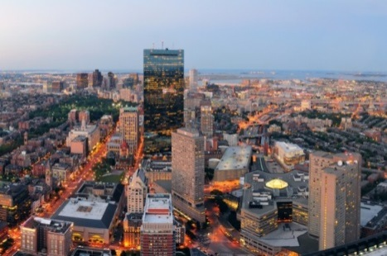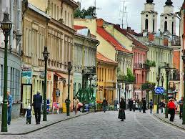

Preliminary Programme
MRU Summer School

“Tourism in the twenty-first century: reflections and experiences”
June 26 — July 3, 2016

Venue: MRU LAB Building
Didlaukio str. 55, Vilnius LT-08303, Lithuania

Sunday June 26

Arrival to Vilnius, registration
Accommodation at Students’ House

Monday, June 27

09.20—9.50 Breakfast
10.00—10.45 Opening, greeting words
10.45 – 11.00 Coffee break
11.10 – 12.10 Lecture and seminar (“Lithuanian tourism geography” – Mykolas Romeris University, Dr. Rima Jakytė)
12.15—12.45 Lunch
12.50—14.15 Lecture and seminar (“Lithuanian tourism geography: Workshop” – Mykolas Romeris University, Dr. Rima Jakytė)
Free-time

Tuesday, June 28

09.30—10.00 Breakfast
10.10 – 11.50 Presentation about Azerbaijan (Azerbaijani students) Presentation about Lithuania (Lithuanian students)
12.00 – 12.45 Lunch
12.50 – 14.00 Lecture and seminar (“Gamification in tourism” – Mykolas Romeris University, Lecturer Aistė Kančauskaitė- Jašinskienė)
14:00—14:15 Coffee break
14.15 – 16.00 Lecture and seminar (“Gamification in tourism: Workshop” – Mykolas Romeris University, Lecturer Aistė Kančauskaitė - Jašinskienė),
16:30 – 18:30 Excursion to Vilnius Old Town and Užupis (depending on the weather).

Wednesday, June 29

09.30—10.00 Breakfast
10.10 – 11.50 Lecture and seminar (“The active leisure sector in Europe: developments and challenges” – Mykolas Romeris University Prof. Dr. Vilma Čingienė)
12.00 – 12.45 Lunch
12.50 – 18:30 The active leisure and learning (Mykolas Romeris University Prof. Dr. Vilma Čingienė)

Thursday, June 30

09.30—10.00 Breakfast
10.10 – 11.50 Lecture and seminar (“Medical tourism. Health resorts in Lithuania” – Mykolas Romeris University, Lecturer Ligita Daukšaitė)
12.00 – 12.45 Lunch
12.50 – 14.20 Lecture and seminar (“Risk evaluation in disaster management for tourism “– Mykolas Romeris University, Assoc. Prof. Dr. Arvydas Survila),
14:30—18:30 Free time

Friday, July 1

09.30—10.00 Breakfast
10.10 – 12.00 Lecture and seminar (“Sustainable Tourism – Challenges and Opportunities” – Lecturer Alina Katunian)
12.15—12.45 Lunch
12.50—14.20 Lecture and seminar (“Sustainable Tourism – Challenges and Opportunities: Workshop” – Lecturer Alina Katunian)
14.30—15.00 Closing Ceremony

Saturday, July 2
9:30—10.00 Breakfast
11.00 – 16.00 Trip to Trakai
Sunday, July 3

Departure

MRU Summer School

“Tourism in the twenty-first century: reflections and experiences”
June 26— July 3, 2016

June 26th - July 3th, 2016 the International Summer School “Tourism in the twenty-first century: reflections and experiences” will be held at Mykolas Romeris University, Vilnius, Lithuania.

The International Summer School organizing committee has prepared a special programme for better understanding of the Tourism sector.
During the programme students will be familiarized with:
- tourism geography,
- sustainable tourism,
- sport, medical and adventure tourism,
- risk evaluation in disaster management for tourism.
Students will work in an interactive format, engage in discussions, and work in groups as well.

After academic programme, cultural events and tours will be offered. Cultural events will include a guided tour around Vilnius Old Town and excursion to Užupis. There will be a possibility to visit Trakai (one of the most famous historical site outside Vilnius, which in ancient times was the Royal residency and former capital of Lithuania).

Price per person: 250 EUR - includes breakfast, lunch and coffee breaks, throughout summer school, excursion trips, publishing materials, accommodation at Mykolas Romeris University guest house; stationary, as well as transport throughout the Summer School.

Deadline for registration and payment: June 6, 2016.

Registration will be done by filling the attached application form and emailing it to: daciulyte@mruni.eu and brigitaz@mruni.eu

Bank account details:
Account holder: Mykolas Romeris University Address: Ateities str. 20, 08303 Vilnius, Lithuania Bank: "Swedbank" AB
Address: Konstitucijos ave. 20A, 03502 Vilnius, Lithuania Bank account: LT857300010002492590
Bank Code: 73000 SWIFT/BIC: HABALT22
Purpose of payment: for MRU Tourism Summer School

Contact Personnel: Rūta Dačiulytė daciulyte@mruni.eu
Brigita Žuromskaitė brigitaz@mruni.eu

